pCOLAD for Dynamo is about multidisciplinary parametric design. The idea is that different disciplines use some crucial shared parameters and are immediately informed if a value of a shared parameter is changed. Since a CSV file is easy for all disciplines to handle, we need a pCOLLECT node to gather the crucial parameters and values in the Dynamo solution. Then add several pCOLLECT nodes to a List Create node and link that to a pSHARE node, that displays a copy of the CSV file (a xaml control with a DataGrid bound to a DataTable) and adds the output of pCOLLECT. Then pPARAM nodes use the output of pSHARE to find the parameters and values that are needed from other team members. Of course it is more complex than this. In order to understand what a parameter is about, you have to add several attributes. This must be flexible. So pCOLLECT should have the possibility to add parameter inputs. And some smart mapping of different attributes is needed.  
[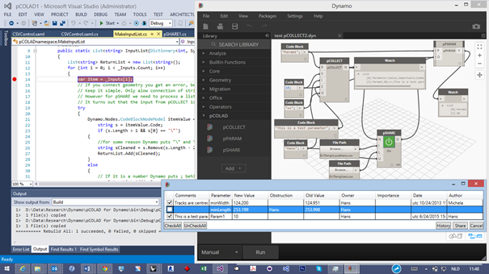](https://cloud.githubusercontent.com/assets/1529297/8499977/5915b996-2198-11e5-8b43-cb9c75203924.png)